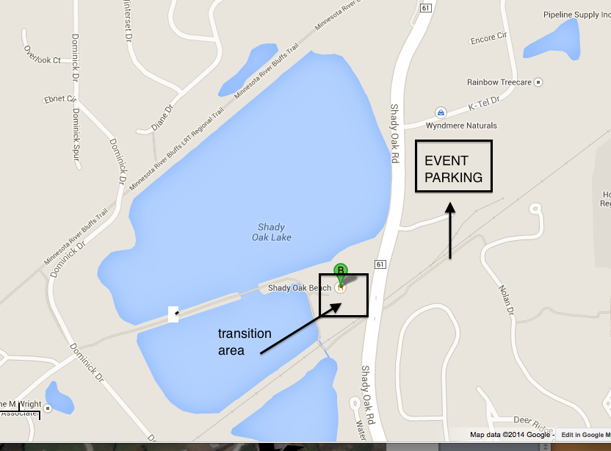

Parking and Transition Area:
Take Shady Oak Road to K-tel Drive, then walk across Shady Oak Road at the stop light to get to the transition area

