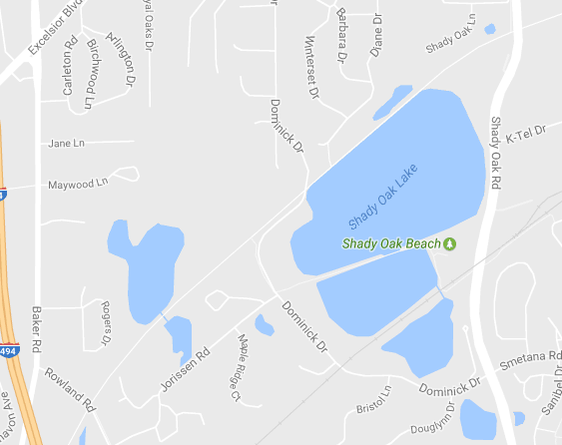

RUN COURSE KEY

Sprint (5K):

Mini-Sprint (1.75 mile):

Water Station: **W**

5K Mile Markers: **1, 2 and 3**

**2**

**3**

**1**

finish

Dominick

trail

lake

**W**

**W**

**W**

Sprint 5K

lake

Sprint 5K

turnaround

Sprint 5K

Transition area

lake