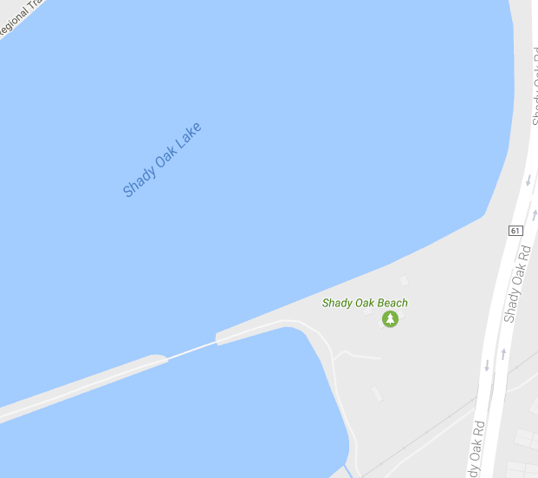

SWIM START

SWIM COURSE KEY

Sprint (750 yards):

Mini-Sprint (100 yards):

Transition

Area

BIG DOCK